https://playwright.dev/docs/test-assertions

await expect(page.locator('.status')).toHaveText('Submitted');
await expect(page).toHaveURL(/.*\/login/);
await expect(page).toHaveScreenshot('image.webp');
await expect(page).toHaveTitle(/.*checkout/);
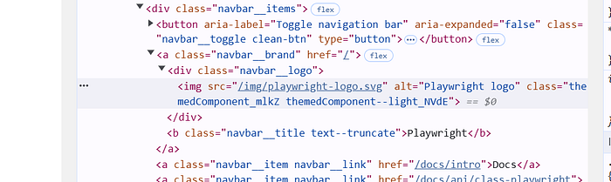
const logoElement = await page.getByAltText('Playwright logo')
await expect(logoElement).toBeVisible()
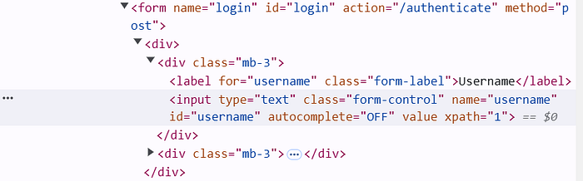
const userNameTextField = await page.locator('#username')
await expect(userNameTextField).toBeEnabled()
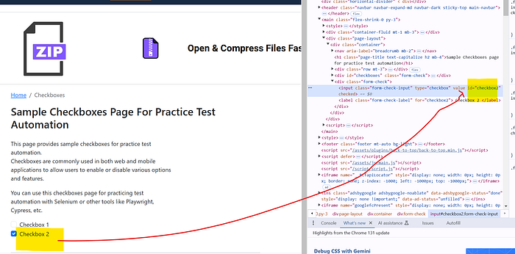
const checkBoxTwo = await page.locator('#checkbox2')
await expect(checkBoxTwo).toBeChecked()
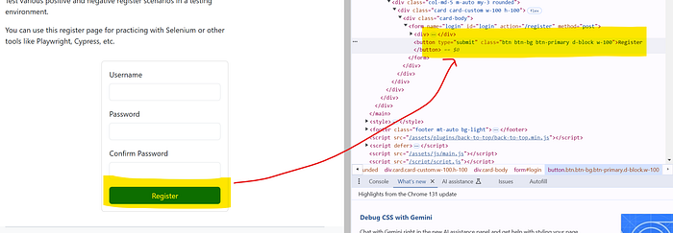
const registerButton = await page.locator("button[type='submit']")
await expect(registerButton).toHaveText('Register')
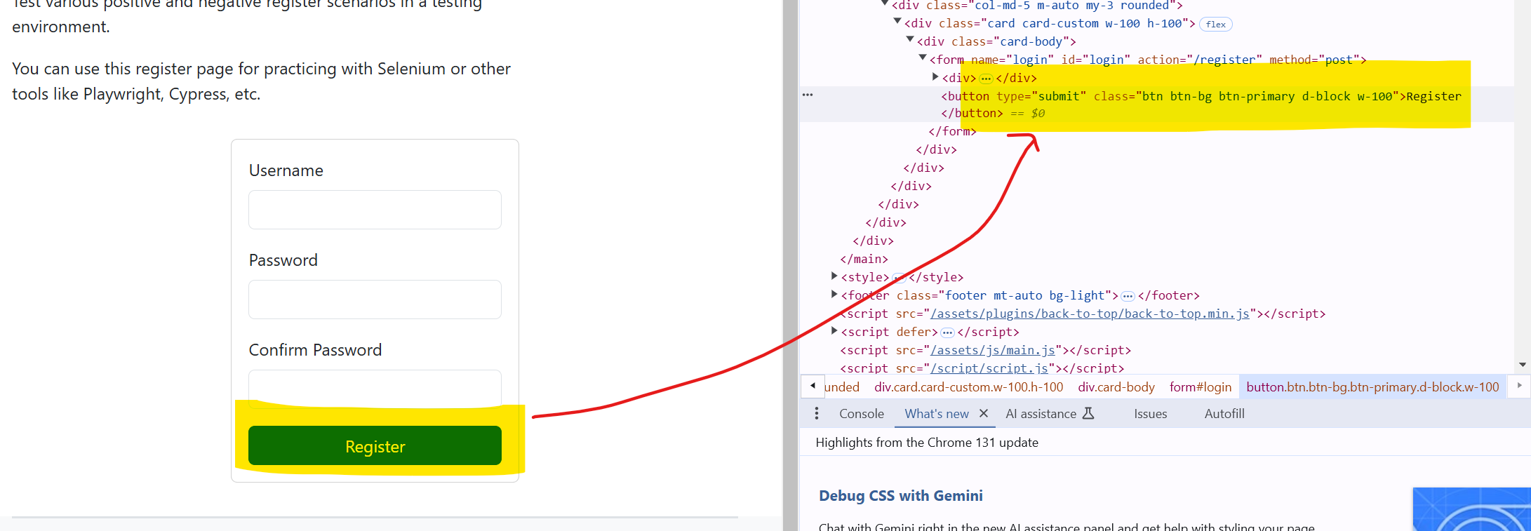
// Check elements contains text - check partial value
const registerButton1 = await page.locator("button[type='submit']")
await expect(registerButton).toContainText('Reg')
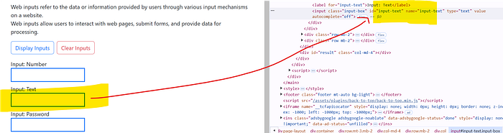
const textField = await page.locator("#input-text")
await textField.fill('Test')
await expect(textField).toHaveValue('Test')

